Campus Connect

Presented to the Application Development

Emerging Technologies

In Partial Fulfillment of the Requirements for the Degree

Bachelor of Science in Information Technology

By :

Borbon, Aljhon R.

Instructor:

Jerome Geli

February 14,2026

App Name: CampusConnect
Category: Student Services Application1. Introduction

1.1 Background of the System
In many educational institutions, student service requests are still processed manually. Students must physically visit offices to request documents, schedule counseling, or report maintenance concerns. This traditional process often leads to long queues, misplaced forms, delayed responses, and lack of transparency.
To address these challenges, CampusConnect is proposed as a digital solution that centralizes and automates student service management.

1.2 Purpose of the Application

The system aims to:
- Provide a centralized platform for student services
- Reduce manual processing and paperwork
- Improve communication between students and staff
- Enable real-time tracking of service requests
- Increase efficiency and transparency in service delivery

1.3 Scope of the Application

The system includes the following functionalities:

User registration and login

Viewing available services

Submitting service requests

Tracking request status

Admin panel for managing requests

The system is accessible through web browsers and is designed to be responsive on both desktop and mobile devices.

2. App Overview

This section provides a general description of CampusConnect, explaining what the application does, who will use it (students, staff, and administrators), and how it operates as a web-based system accessible through browsers.

2.1 App Description
CampusConnect is a web-based student services management system that allows students to submit and monitor service requests online.

What the app does:
- Enables online service request submission
- Allows tracking of request progress
- Provides dashboard for staff to manage requests

Intended Users:
- Students
- Office Staff
- Administrators

Platform:
Web Application (Desktop and Mobile Browser)

3. Stakeholders and Users

This section identifies the key individuals and groups involved in the system. It defines the responsibilities and access levels of students, staff members, administrators, and other stakeholders.

3.1 Primary Stakeholders
- Students
- Service Staff
- System Administrator

3.2 Secondary Stakeholders
- IT Administrator
- School Management

3.3 User Roles
Student
- Register and login
- Submit service requests
- Receive notifications
- Track request status
Staff/Admin
- View assigned requests
- Update request status
- Approve or resolve requests
- Monitor system activity

4. Requirement Specifications

This section outlines the technical and operational needs of the system. It includes functional requirements that describe the features of the app and non-functional requirements that focus on performance, security, usability, and reliability.

Functional Requirements
FR1: The system shall allow user registration and secure login
FR2: The system shall display available services
FR3: The system shall allow submission of service requests
FR4: The system shall track request status (Pending, In Progress, Completed)
FR5: The system shall provide an admin dashboard
FR6: The system shall send automated notifications
FR7: The system shall implement role-based access control

Non-Functional Requirements
NFR1: The system shall ensure secure authentication
NFR2: The system shall have fast performance
NFR3: The system shall be mobile-responsive
NFR4: The system shall be user-friendly
NFR5: The system shall ensure data privacy and protection

5. App Architecture

explains the overall system structure, including the selected Canvas App type and the three-tier architecture composed of the presentation layer, application logic layer, and data layer.

5.1 Selected Type
Selected App Type: Canvas App

Justification – Why this app type is suitable?
- Allows custom user interface design
- Ideal for form-based applications
- Provides better user interaction
- Simple data relationships
A Model-Driven App is not suitable because the system focuses more on user experience rather than complex data structures.

5.2 High-Level Architecture
Overall System Structure:
Student (User Interface)
↓
Web Application (Frontend)
↓
Application Server (Backend Logic)
↓
Database Server (MySQL / SQL Server)

The system follows a three-tier architecture:
- Presentation Layer
- Application Logic Layer
- Data Layer

6. Data Model Design

In the CampusConnect – Student Services App, Data Modeling Design defines how student service information is structured and stored in the database. It identifies the main entities such as Users, Services, Requests, and Request_Status, including their attributes and relationships.

6.1 Data Sources
- MySQL Database
- Email Notification System

6.2 Entities and Attributes

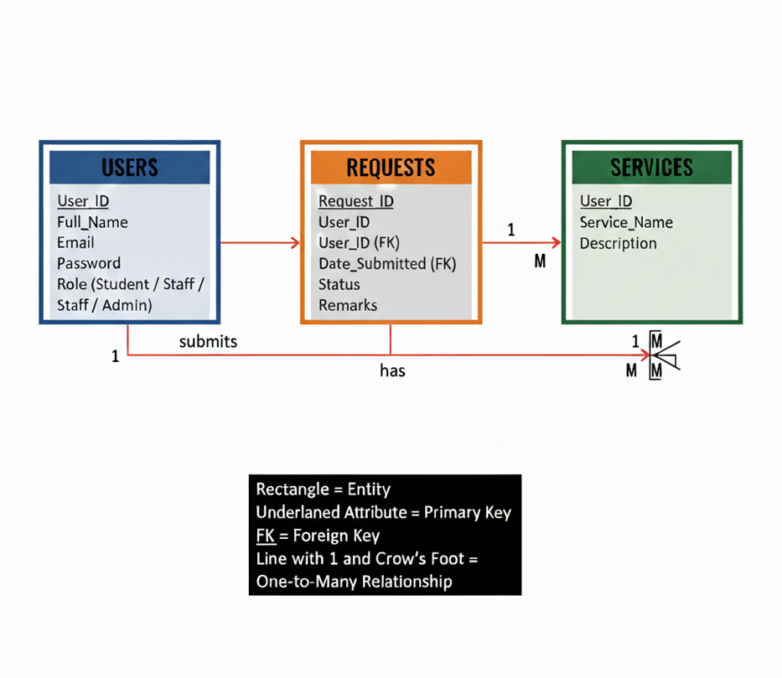

6.3 Relationships
One User can have many Requests
One Service can have many Requests
(ERD should include primary and foreign key relationships.)

7. Key Functionalities
The Key Functionalities section outlines the essential features that make CampusConnect an efficient and reliable student services application. It describes the core capabilities of the system, including online service request submission, a request tracking dashboard, and an admin management panel. This section also explains the automation workflows that ensure smooth processing of requests, such as automatic status updates and real-time notifications. In addition, it highlights the business logic and validation rules that maintain data accuracy, security, and proper access control for students and staff. Together, these functionalities ensure a structured, transparent, and user-friendly service management process.

7.1 Core Features
- Online service request submission
- Request tracking dashboard
- Admin management panel

7.2 Automation and Workflows

The system follows an automated workflow:

Pending → In Progress → Completed

Each status update triggers a notification to the user.

7.3 Business Logic and Validation

Users cannot submit incomplete forms

Students can only view their own requests

Staff can only access assigned requests

Required fields must be validated

8. User Interface and Design
The User Interface and Design section focuses on how CampusConnect is visually structured and how users interact with the system. It emphasizes a simple and clean layout, easy navigation, responsive design, and clear status indicators to ensure a smooth and user-friendly experience. This section also presents the wireframes and mockups of the main screens, including the Login Screen, Student Dashboard, Service Selection Page, Request Form Page, My Requests Page, and Admin Panel. Additionally, it explains the navigation flow and basic data flow of the system, showing how users move through the application and how information is processed from submission to notification.

8.1 Design Principles
- Simple and clean layout
- Easy navigation
- Responsive design
- Clear status indicators

8.2 Wireframes / Mockups
Main Screens:
- Login Screen
- Student Dashboard
- Service Selection Page
- Request Form Page
- My Requests Page
- Admin Panel

8.3 Navigation Flow
Login
↓
Dashboard
↓
Select Service
↓
Fill Form
↓
Submit
↓
Track Status

Basic Data Flow

Student submits request → Data stored in database → Staff processes request → Status updated → Student receives notification

PROTOTYPE
